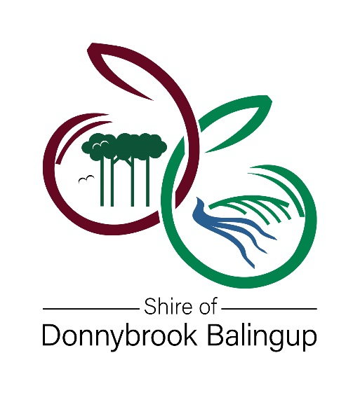

Community Grant Funding Scheme
FOR FINANCIAL YEAR 2021 – 2022

MINOR FUNDING APPLICATION
Maximum $500
Please read the Community Grant guidelines before completing this Application Form

ORGANISATION NAME

PROJECT OR EVENT NAME | AMOUNT REQUESTED

FUNDING TYPE REQUESTED (Select only one)
COMMUNITY GRANT | EVENT SPONSORSHIP | WAIVER OF FEE/S

THE APPLICATION PROCESS
Applications are open all year round.
Applications for Minor Grants, Minor Event Sponsorship & Waiver of Fee/s should be submitted a minimum of 8 weeks prior to the Project/Activity/Event.

APPLICATION CHECKLIST
Prior to submitting your application, please complete the checklist below to confirm that all requested information has been included. Incomplete applications will be not be considered.

The application form has been signed by the Chairperson or President of the organisation.

The application clearly specifies what the funding is to be used for,
AND answers have been provided for every question – please attach any additional information you feel will give more weight to your application.

Any previous funding (Community Grant, Event Sponsorship or Recurrent Funding) has been acquitted.

If your application is for capital works, copies of plans and costings have been attached (with a letter or permission if the applicant is not the owner of the premise)

If your application is for an event, a copy of the event budget including all projected income and expenditure has been included.

All mandatory supporting documentation is attached including a copy of current registration/incorporation and insurance certificate of currency.

All quotes are included for any purchases

Please address application to:
Chief Executive Officer
Community Grant Application
Shire of Donnybrook Balingup
PO Box 94
Donnybrook WA 6239

Applications can be lodged in person, post or email:
communitydevelopment@donnybrook.wa.gov.au

APPLICANT DETAILS
Organisation Name
Chairperson or President
Organisation Postal Address

Main Contact Person
Position
Email
Phone

Status of organisation
 | Yes | Incorporated Association (include a copy of Certificate of Incorporation)
 | No | Name of Auspicing Body (include a copy of the auspicing bodies Certificate of Incorporation)
 | Cooperative
 | Established Community Group
 | Other – Provide details:

Does your organisation have an ABN? |  | Yes | ABN:
 |  | No

Is your organisation registered for GST? |  | Yes |  | No

Has this organisation previously received a Community Grant or Budgetary Funding from the Shire of Donnybrook Balingup?  If yes, please provide the following details for the most recent Community Grant or Budgetary Funding you have received. |  |  |  | Yes
 |  |  |  | No
Project Name
Organisation Name
Grant Amount | $
Year grant funded |  | Year grant acquitted
PROJECT SUMMARY
Amount requested | $
Amount contributed by you (the applicant) | $

Project Description – CLEARLY explain what the funding is for?

PROJECT TIMEFRAME AND BENEFITS

Project Commencement Date
Projected Completion Date

Provide a brief description of the expected benefits of your project/activity/event?

Have you applied for other grant funding? If yes, who did you apply to and how much was that application for? Please CLEARLY show this in the project budget.

Does your project just benefit your own group OR provide benefit to the wider community? Please CLEARLY explain how others will benefit from your project.

Are you working with any other community groups to achieve your project? If yes, please list each group involved in the project AND how they are supporting the project.

PROJECT BUDGET
- Project budgets are required for applications to be considered.
- Item numbers in left column assist with calculating final budget totals.
- Please complete all sections. If you have queries, please contact the Community Development team on 9780 4200.

INCOME
INTERNAL FUNDING – CASH AMOUNT
1 Applicant’s cash contribution |  |  |  | $
2 Other cash contribution from: |  |  |  | $
3 Volunteer hours: |  | hours @$41.72/hour  Figure based on ABS average hourly earnings estimate for volunteers, published on the Funding Centre.  https://www.fundingcentre.com.au/grant/help |  | S
4 Other: |  |  |  | S
5 TOTAL INTERNAL FUNDING (SUM 1:4) $
EXTERNAL FUNDING AMOUNT
6 Shire of Donnybrook Balingup |  |  |  | $
7 Funding Organisation 1: |  |  |  | $
8 Funding Organisation 2: |  |  |  | $
9 Participant Fees (if applicable) |  |  |  | $
10 Other: |  |  |  | S
11 Other: |  |  |  | $
12 TOTAL EXTERNAL FUNDING (SUM 6:11) $
13 TOTAL INCOME (5 + 12) $
Note: Total income (12) must be equal to total expenditure (27)
EXPENDITURE
PROMOTIONS & ADMINISTRATION |  |  | FUNDING ORG | AMOUNT
14 Promotional Materials |  |  |  |  | $
15 Telephone |  |  |  |  | $
16 Postage and Stationery |  |  |  |  | $
17 Photocopying |  |  |  |  | $
18 Insurance |  |  |  |  | $
19 Travel & accommodation costs |  |  |  |  | $
20 Venue Hire |  |  |  |  | $
21 Equipment Costs |  |  |  |  | $
22 Refreshments |  |  |  |  | $
23 Guest Speaker/Presenter fee |  |  |  |  | $
24 Other |  |  |  |  | $
25 Other |  |  |  |  | $
26 Other |  |  |  |  | $
27 TOTAL EXPENDITURE $
Note: Total Income (13) must be equal to Total Expenditure (27)

Total Cost of Project/Event (34) | $
Amount of Council Funding (6) | $
Your Internal Funding (5) | $
Contribution from Other Sources (12 – 6) | $

GENERAL FUNDING CONDITIONS
- The Shire of Donnybrook Balingup will not accept this application if it is late or incomplete
- Council may use the information provided by the funded entity for its own promotional purposes.
- All funded entities will be required to enter into an agreement with the Shire of Donnybrook Balingup which will detail specific conditions and terms relevant to that project.
- All funded entities must acknowledge the support of the Shire of Donnybrook Balingup in all their promotional material.
- Funded entities must advise the Shire of Donnybrook Balingup of any change to office bearers and their contact details.
- Payment for the grant funding occurs after the project has been completed and the acquittal documents has been received.
- If the application is successful the group/organisation is required to lodge the acquittal documents within 3 months of the completion date, or 30 June 2021 whichever is earliest.
- The acquittal documents include:
- Acquittal form.
- Tax invoice.
- GST Grant Contribution form.
- If no ABN a Statement by Supplier form.

SPECIFIC GRANT CONDITIONS
If there are any specific grant conditions, unique to your application these will be included in the letter of advice confirming your application has been successful.

Public Liability Insurance
If you are a community group that uses Council facilities more than ten times in financial year, you will need to provide a Public Liability Insurance Certificate of Currency. If you are an Incorporated Body or affiliated to a sporting body, you will require Public Liability Insurance to use Council facilities.
If the activity is officially managed by the Shire, e.g. a class coordinated by the Shire’s Recreation Centre, your own Public Liability Insurance is not required.

Does your organisation had Public Liability Insurance? If yes, please state the value of your current Public Liability Insurance and attach a copy of the insurance policy.
 | Yes |  | Copy enclosed | Insured Amount: | $
 | No

Only the Chairperson, President of Authorised Person of your group should sign this application
I, the undersigned, certify that to the best of my knowledge the statements made within this application are true.
I understand that if the Shire of Donnybrook Balingup approves this application for funding, I will be required to accept the Funding Conditions as outlined above.
Name
Position
Signature
Date

