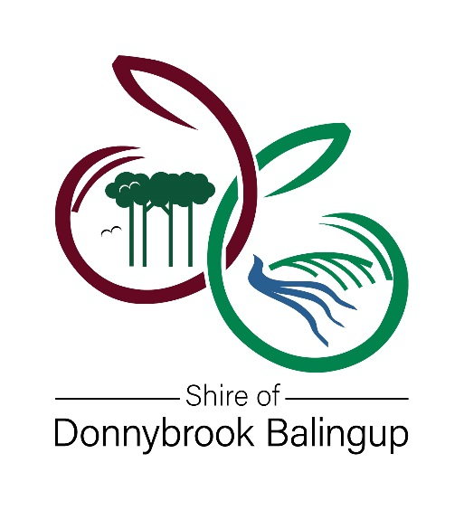

MAJOR FUNDING APPLICATION
FOR FINANCIAL YEAR 2022 - 2023
Maximum $2,000
Please read the Community Grant guidelines before completing this Application Form

ORGANISATION NAME

PROJECT OR EVENT NAME

FUNDING TYPE REQUESTED (Select only one)
COMMUNITY GRANT | EVENT SPONSORSHIP

APPLICANT DETAILS
Organisation Name
Chairperson or President
Organisation Postal Address

Main Contact Person
Position
Email
Phone

Status of organisation
 | Yes | Incorporated Association (include a copy of Certificate of Incorporation)
 | No | Name of Auspicing Body (include a copy of the auspicing bodies Certificate of Incorporation)
 | Established Community Group
 | Other – Provide details:

Does your organisation have an ABN? |  | Yes | ABN:
 |  | No

Is your organisation registered for GST? |  | Yes |  | No

Has this organisation previously received a Community Grant or Budgetary Funding from the Shire of Donnybrook Balingup?  If yes, please provide the following details for the most recent Community Grant or Budgetary Funding you have received. |  |  |  | Yes
 |  |  |  | No
Project Name
Organisation Name
Grant Amount | $
Year grant funded |  | Year grant acquitted

PROJECT SUMMARY
Amount requested | $
Amount contributed by you (the applicant) | $

Project Description – CLEARLY explain what the funding is for?

PROJECT TIMEFRAME AND BENEFITS

Project Commencement Date
Projected Completion Date

Why is the project important? Provide a brief description of the anticipated number of people that will benefit from the project, directly and indirectly. How will that be measured?

Have you applied for other grant funding? If yes, who did you apply to and how much was that application for? Please CLEARLY show this in the project budget.

Does your project just benefit your own group OR provide benefit to the wider community? Please CLEARLY explain how others will benefit from your project.

Are you working with any other community groups to achieve your project? If yes, please list each group involved in the project AND how they are supporting the project.

PROJECT BUDGET
- Project budgets are required for applications to be considered.
- Item numbers in left column assist with calculating final budget totals.
- The included items are for assistance, please add/remove as needed.
- Please complete all sections. If you have queries, please contact the Community Development team on 9780 4200.

INCOME
INTERNAL FUNDING – CASH AMOUNT
1 Applicant’s cash contribution |  |  |  | $
2 Other cash contribution from: |  |  |  | $
3 Volunteer hours: |  | hours @$41.72/hour  Figure based on ABS average hourly earnings estimate for volunteers, published on the Funding Centre.  https://www.fundingcentre.com.au/grant/help |  | S
4 Other: |  |  |  | S
5 TOTAL INTERNAL FUNDING (SUM 1:4) $
EXTERNAL FUNDING AMOUNT
6 Shire of Donnybrook Balingup |  |  |  | $
7 Funding Organisation 1: |  |  |  | $
8 Funding Organisation 2: |  |  |  | $
9 Participant Fees (if applicable) |  |  |  | $
10 Other: |  |  |  | S
11 Other: |  |  |  | $
12 TOTAL EXTERNAL FUNDING (SUM 6:11) $
13 TOTAL INCOME (5 + 12) $
Note: Total income (12) must be equal to total expenditure (36)
EXPENDITURE
PROFESSIONAL SERVICES |  |  | FUNDING ORG | AMOUNT
14 Consultant fees |  |  |  |  | $
15 Accounting & bookkeeping costs |  |  |  |  | $
16 Salaries for paid staff |  |  |  |  | $
17 Honoraria for service providers |  |  |  |  | $
18 Other |  |  |  |  | $
19 Other |  |  |  |  | $
20 TOTAL PROFESSIONAL SERVICES (SUM 14:19) $

PROMOTIONS & ADMINISTRATION | FUNDING ORG | AMOUNT
21 Promotional Materials |  |  | $
22 Telephone |  |  | $
23 Postage and Stationery |  |  | $
24 Photocopying |  |  | $
25 Insurance |  |  | $
26 Other |  |  | $
27 Other |  |  | $
28 TOTAL PROMOTIONAL & ADMINISTRATION EXPENSES (SUM21:27) $
TRANSPORTATION & VENUES | FUNDING ORG | AMOUNT
29 Travel & accommodation costs |  |  | $
30 Venue Hire |  |  | $
31 Equipment hire |  |  | $
32 Refreshments |  |  | $
33 Other |  |  | $
34 Other |  |  | $
35 TOTAL TRANSPORTATION & VENUE EXPENSES (SUM 29:34) $
36 TOTAL EXPENDITURE (20 + 28 + 35) $
Note: Total Income (13) must be equal to Total Expenditure (36)

Total Cost of Project/Event (34) | $
Amount of Council Funding (6) | $
Your Internal Funding (5) | $
Contribution from Other Sources (12 – 6) | $

Only the Chairperson, President of Authorised Person of your group should sign this application.
I, the undersigned, certify that to the best of my knowledge the statements made within this application are true.
I understand that if the Shire of Donnybrook Balingup approves this application for funding, I will be required to accept the Funding Conditions as outlined above.
Name
Position
Signature
Date

GENERAL FUNDING CONDITIONS
- The Shire of Donnybrook Balingup will not accept this application if it is late or incomplete.
- Council may use the information provided by the funded entity for its own promotional purposes.
- All funded entities will be required to enter into an agreement with the Shire of Donnybrook Balingup that will detail specific conditions and terms relevant to that project.
- All funded entities must acknowledge the support of the Shire of Donnybrook Balingup in all their promotional material.
- Funded entities must advise the Shire of Donnybrook Balingup of any change to office bearers and their contact details.
- Payments of grants or budget item funding may be suspended at any time, if in the opinion of the Shire, any of the conditions of the funding agreement, or satisfactory progress, has not been achieved.
- Any change to a funded project cannot proceed without formal approval from the Shire – the applicant must submit a written grant variation request to the Shire of Donnybrook Balingup clearly stating any proposed changes to the project and the reason why the changes are required. This will be considered by the Shire and a determination made.
- Payment for the grant funding occurs once a tax invoice is received from the recipient. Payment can be made as soon as the grant/event sponsorship has been approved. When the project is completed a grant acquittal form is required to be completed along with evidence the grant has been used for the intended purpose.

SPECIFIC GRANT CONDITIONS
If there are any specific grant conditions, unique to your application these will be included in the letter of advice confirming your application has been successful, following the Councils consideration of 2022 - 2023 budget and its acceptance in August/September 2022.

APPLICATION CHECKLIST
Prior to submitting your application, please complete the checklist below to confirm that all requested information has been included. Incomplete applications will not be considered.

The application form has been signed by the Chairperson or President of the organisation.

The application clearly specifies what the funding is to be used for,
AND answers have been provided for every question – please attach any additional information you feel will give more weight to your application.

Any previous funding (Community Grant, Event Sponsorship or Recurrent Funding) has been acquitted.

If your application is for capital works, copies of plans and costings have been attached (with a letter or permission if the applicant is not the owner of the premise)

If your application is for capital works and the organisation is not the
Owner of the premises, written permission form the owner has been included.

If your application is for an event, a copy of the event budget including all projected income and expenditure has been included.

THE APPLICATION PROCESS
Applications must be received by 4.30pm Friday 25th June 2021.
All applications will receive a written acknowledgement of receipt. The outcome of the application and assessments will only be announced once Council’s Annual Budget has been adopted.

Please address application to:
Chief Executive Officer
Community Grant Application
Shire of Donnybrook Balingup
PO Box 94
Donnybrook WA 6239

