**LOCAL DEVELOPMENT PLAN- COLLINS STREET COMMERCIAL PRECINT**



Locality Plan (note to scale)



Reserve Street

Station Street

Collins Street

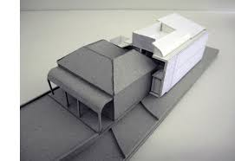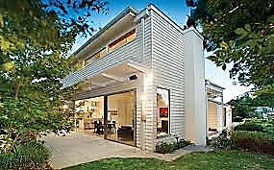

Indicative examples of built form